SUMMER 2018 at Ridgefield’s nonprofit dance education center

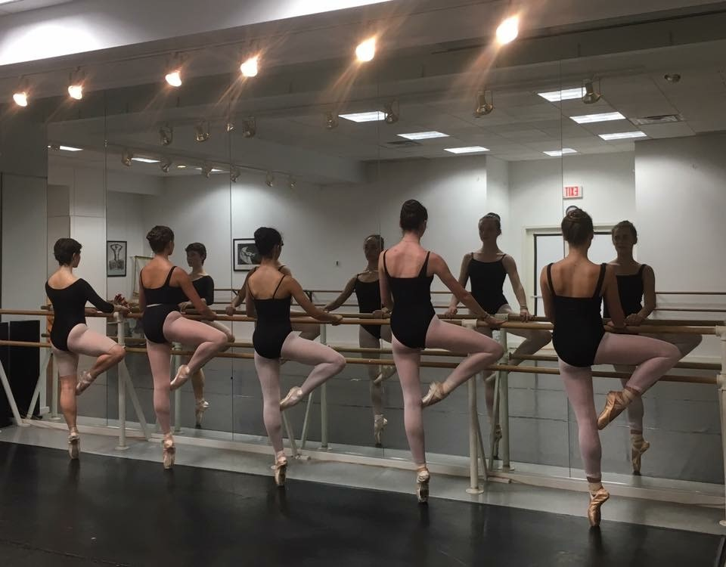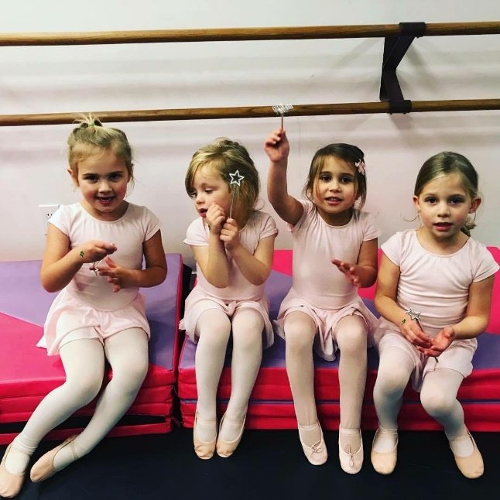

SUMMER CAMP INTENSIVES: WEEK 1: AUGUST 6-10, WEEK 2 AUGUST 13-17

Advanced: Levels III & IV, generally Grades 5-8, 2 years minimum ballet. Ballet Master Alexander Glaz will guide each student carefully in a current, mindful approach to their ballet training, and students also take Jazz, Musical Theater, yoga/Pilates, and Modern. Special one-time workshops include composition/choreography, stagecraft, audition techniques, and stage make-up application. M-F, 10:15 – 5:00. 1 week $695, 2 weeks $1195, plus $60 annual reg. fee for new students.

Intermediate: Levels I & II, generally Grades 2-4, or older beginners. Similar to our Advanced offering, but scaled back a bit for our younger dancers. Students get a comprehensive varied schedule which includes daily ballet with Mr. Glaz, conditioning, modern, jazz, contemporary, and hip hop. M-F, 10:45 – 4:00. 1 week $595, 2 weeks $1095, plus a $60 annual registration fee for new students. Extended day morning option from 8:30 – 10:45 available at $20/day.
Junior: Pre-ballet dancers entering Kindergarten through second grade. For youngsters focused on accelerating their dance technique, this program is for you! Ballet with Miss Amy, Modern, and Jazz with a daily Yoga/Pilates wake-up or Nutcracker repertory will keep your little dancer busy. Morning and afternoon extended day options from 8:30 - 9:30 and 1:30 – 4:00. 1 week $395, 2 weeks $750, plus $60 annual registration fee for new students. Extended day morning: $10/day Extended day afternoon: $20/day.
OPEN DROP-IN CLASSES:
No need to pre-register for our drop-in classes. Weeks of July 23 & 30 and August 6 & 13 ONLY. Single class is $30 (Pointe is a half class). 10-class card is $270.
Monday: Intermediate/Advanced Ballet, age 12+, 5:30-7:00 For more information, visit ridgefielddance.org, email
Tuesday: Ballet I/II 4:30-5:30, Ballet III/IV 5:30-7:00, Jazz III/IV 7-8, Jazz V/VI 8-9 information@ridgefielddance.org,
Wednesday: Intermediate/Advanced Ballet, age 12+, 5:30-7:00, Pointe 7:00-7:45 or call 203-438-5597.

