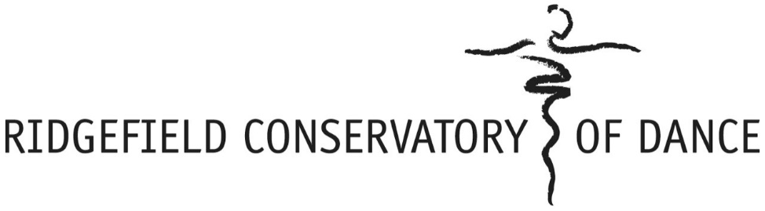
SUMMER 2019 at Ridgefield’s nonprofit dance education center

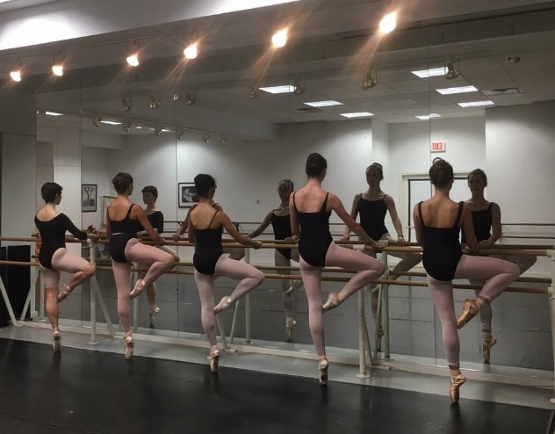
Registration opens March 1. Open to all dancers in the community!

SUMMER CAMP INTENSIVES KINDERGARTEN THROUGH 8TH GRADE
WEEK 1: AUGUST 12-16, WEEK 2 AUGUST 19-23.

Advanced: Levels III & IV, generally Grades 5-8, 2 years minimum ballet. Ballet Master Alexander Glaz will guide each student carefully in a current, mindful approach to their ballet training, and students also take Jazz, Musical Theater, yoga/Pilates, Modern, and Special Workshops. M-F, 10:15 – 5:00. 1 week $695, 2 weeks $1195.

Intermediate: Levels I & II, generally Grades 2-4, or older beginners. Similar to our Advanced offering, but scaled back a bit for our younger dancers. Students get a comprehensive varied schedule which includes daily ballet with Mr. Glaz, conditioning, modern, jazz, contemporary, and hip hop. M-F, 10:45 – 4:00. 1 week $595, 2 weeks $1095. Extended day morning option from 8:30 – 10:45 available at $20/day.
Junior: Pre-ballet dancers entering Kindergarten through second grade. For youngsters focused on accelerating their dance technique, this program is for you! Ballet, Modern, and Jazz with a daily Yoga/Pilates wake-up or Nutcracker repertory will keep your little dancer busy. **See reverse side for dancers age 3 & 4. Morning and afternoon extended day options from 8:30 - 9:30 and 1:30 – 4:00. 1 week $395, 2 weeks $750.. Extended day morning: $10/day Extended day afternoon: $20/day.

AUGUST OPEN DROP-IN CLASSES FOR GRADE 2 - ADULT:
No need to pre-register for our drop-in classes. THREE WEEKS: August 5, 12 & 16 ONLY. Single class is $30 (Pointe is a half class). 10-class card is $270.
For more information, visit ridgefielddance.org, email
Tuesday: Ballet I/II 4:30-5:30, Ballet III/IV 5:30-7:00, Jazz III/IV 7-8, Jazz V/VI 8-9 information@ridgefielddance.org,
Wednesday: Intermediate/Advanced Ballet, age 12+, 5:30-7:00, Pointe 7:00-7:45 or call 203-438-5597.
Friday: Adult Intermediate Ballet, 12 noon-1:30, Intermediate/Advanced Ballet, age 12+, 5:30-7:00, Pointe 7:00-7:45

SUMMER 2019 at Ridgefield’s nonprofit dance education center

PRE-BALLET PROGRAMS:

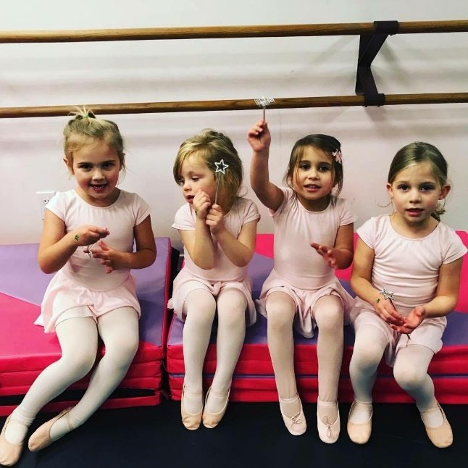
SUMMER CAMP FOR PRESCHOOLERS AGES 3 & 4
August 5-9, 9:30 am – 12 pm
Registration opens March 1. Open to all dancers in the community!

Our young dancers arrive at 9:30 am to enjoy a yoga wake-up class, followed by a craft, ballet class, snack, and modern/jazz dance class. This is a fun introduction to dance camp!
$295 for the week. Dancers entering Kindergarten, see reverse side for summer camp intensives.

THREE WEEK AUGUST SUMMER CLASS PRE-BALLET OPTION
$60/session
Tuesday Dance for 2’s & 3’s: 12:15-12:45 (8/6, 8/13, 8/20)
Tuesday Pre-Ballet I (age 4): 12:45-1:30 (8/6, 8/13, 8/20)
Thurs. Pre-Ballet II: (Kindergarten):12:00-12:45 (8/8, 8/15, 8/22)
Thursday Pre-Ballet III: (First Grade) 12:45-1:30 (8/8, 8/15, 8/22)

