SPRING II DROP-IN CLASS SCHEDULE BY LEVEL
MAY 13- JUNE 13

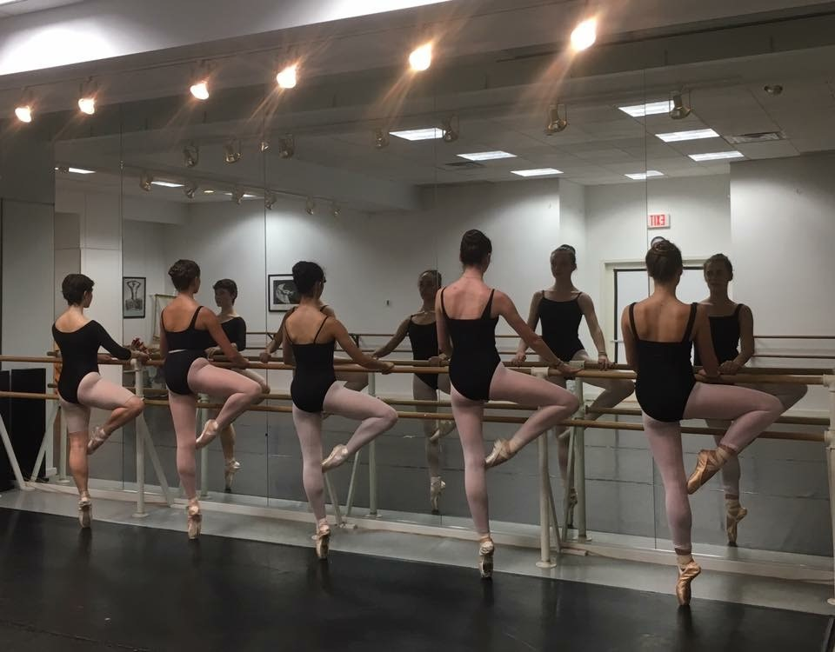

DANCE FOR 2s & 3s:
FRIDAY 1:30-2:00 Dance for 2’s & 3’s, Piantaggini
SATURDAY 9:00-9:30, Dance for 2’s & 3’s, Piantaggini

PRE-BALLET I:
MONDAY 4:45-5:30 Preballet I, Piantaggini
FRIDAY 2:00-2:45 Pre-ballet I, Piantaggini
SATURDAY 9:30-10:15, Pre-Ballet I Piantaggini

PRE-BALLET II:
MONDAY 5:30-6:15 Preballet II, Piantaggini
THURSDAY 5:30-6:15 Pre-Ballet II, Piantaggini
SATURDAY 10:15-11:00, Pre-Ballet II, Piantaggini

PRE-BALLET III:
4:45-5:30 Pre-Ballet III, Piantaggini
SATURDAY11:00-11:45, Pre-Ballet III, Piantaggini

ridgefielddance.org 203-438-5597
$20 Dance for 2s & 3s - Pre-ballet III $30/each Levels I-VI
LEVEL I/II:
MONDAY 4:30-5:30 Ballet I/II, Glaz
TUESDAY 4:45-5:45 Jazz I/II Fusco
THURSDAY 5:15-6:15 Ballet I/II, Glaz
THURSDAY 6:15-7:15 Modern I/II, Piantaggini

LEVEL III/IV:
MONDAY 5:30-6:30 Ballet III/IV, Glaz
TUESDAY 5:45-6:45 Musical Theater III/IV
TUESDAY 6:45-7:45 Jazz III/IV, Fusco
WEDNESDAY 4-5:30 Ballet III/IV, Glaz
WEDNESDAY 5:30-6:15 Pointe IV, Glaz
WEDNESDAY 7:00-8:00 Contemporary, Czyr
THURSDAY 4:15-5:15 Ballet III/IV, Glaz
FRIDAY 5:00-6:00 Modern III/IV, Cortes
SATURDAY 9:00-10:30 Ballet III/IV, Scaia

LEVEL V/VI:
MONDAY 6:30-8 Ballet V/VI, Glaz
TUESDAY 4:45-5:45 Musical Theater V/VI
TUESDAY 5:45-6:45 Jazz V/VI, Fusco
WEDNESDAY 5:15-6:15 Contemporary V/VI, Czyr
WEDNESDAY 6:15-7:45 Ballet V/VI, Glaz
WEDNESDAY 7:45-8:30 Pointe V/VI, Glaz
THURSDAY 6:15-7:45 Ballet V/VI, Glaz
THURSDAY 7:45-8:30, Pte. V/VI, Glaz
FRIDAY 4:00-5:00 Modern V/VI, Cortes
SATURDAY 10:30-12:00 Ballet V/VI, Scaia
SATURDAY 12:00-12:45 Pointe V/VI, Scaia

OPEN LEVEL:
TUESDAY 6:45-7:45 Open Level Tap Jam, Gleason
FRIDAY ADULT BALLET 12-1:30 Adult Intermediate Ballet, Cortes

