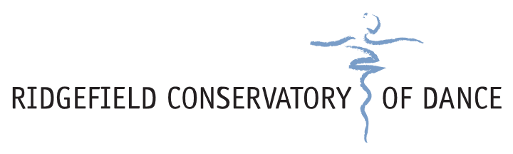

PATRICIA SCHUSTER AWARD APPLICATION

The Patricia Schuster Award honors an RCD student going on to pursue dance training in their professional career or in higher education, following their high school graduation. In each year, the RCD Board of Directors will determine whether a recipient will receive the $1,000 award based on their vote on submitted applications. The award honors our Founder.

- Name of Dancer:_____________________________________
- Birth Date:__________________________________________
- Address:___________________________________________
- Email:_____________________________________________
- Phone:____________________________________________

Please submit a 200-400 word essay describing how the funding will assist you in your next steps. Applications are due 4/15 ahead of the Spring Concert. Submissions may be sent electronically to information@ridgefielddance.org, or mailed to PO Box 615 Ridgefield, CT 06877.

